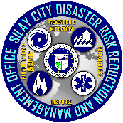


Republic of the Philippines
Province of Negros Occidental
SILAY CITY DISASTER RISK REDUCTION AND MANAGEMENT OFFICE
Aguinaldo Street, Barangay V, Silay City 6116

